**Rooms for the summer school: University of Potsdam, Campus Griebnitzsee, Building 6, ground floor**

**Lecture Hall - H02 (Used in Parallel Sessions on Friday)**

**Lecture Hall - H05 (Used for invited lecturers)**

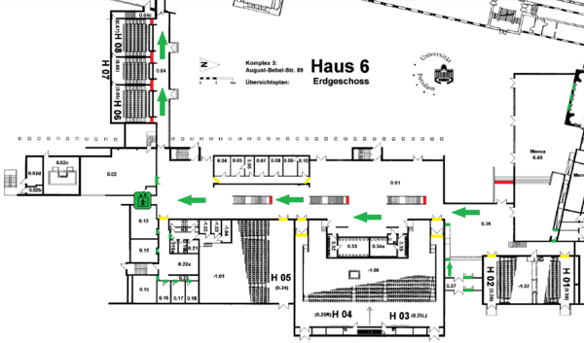

**Rooms for the summer school: University of Potsdam, Campus Griebnitzsee, Building 6, second floor**

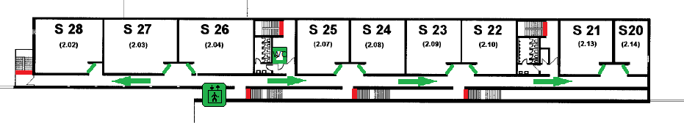

**S22: Introduction to Frequentist statistics**

**S23: Advanced Frequentist methods**

**S24: Introduction to Bayesian statistics**

**S25: Advanced Bayesian methods**

**S26: Registration, Luggage room, Lost and Found, etc.**

**S27: Catering**